UROP PROJECT
M.Mahaboob Basha
AP22110020140
ECE-B

TASK-1
The Task 1 is to collect the data from the sensors and process it in the ESP-32 and show the output in a display
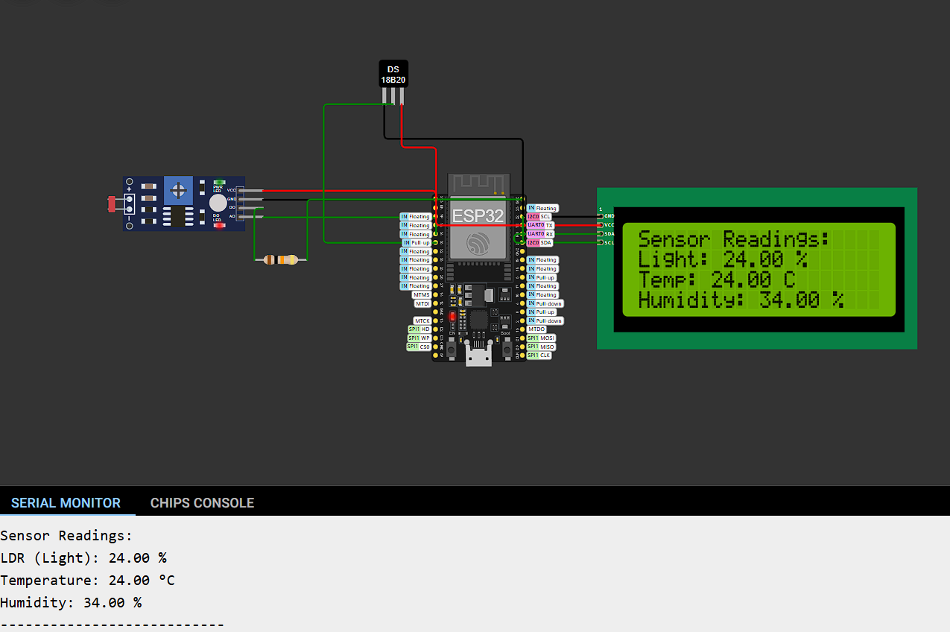
Circuit diagram:

Code:
#include <Wire.h>
#include <LiquidCrystal_I2C.h>
LiquidCrystal_I2C lcd(0x27, 20, 4);
const int ldrPin = 34;
const int tempPin = 35;
const int humPin = 32;
float lightLevel = 0;
float temperature = 0;
float humidity = 0;
void setup() {
Serial.begin(115200);
lcd.init();
lcd.backlight();
lcd.setCursor(0, 0);
lcd.print("Initializing...");
delay(2000);
lcd.clear();
}
void loop() {
lightLevel = map(analogRead(ldrPin), 0, 4095, 0, 100);
temperature = (analogRead(tempPin), 0, 4095, 0, 24);
humidity = map(analogRead(humPin), 0, 4095, 0, 100);
Serial.println("Sensor Readings:");
Serial.print("LDR (Light): "); Serial.print(lightLevel, 2); Serial.println(" %");
Serial.print("Temperature: "); Serial.print(temperature, 2); Serial.println(" °C");
Serial.print("Humidity: "); Serial.print(humidity, 2); Serial.println(" %");
Serial.println("---------------------------");
lcd.clear();
lcd.setCursor(0, 0);
lcd.print("Sensor Readings:");
lcd.setCursor(0, 1);
lcd.print("Light: ");
lcd.print(lightLevel, 2);
lcd.print(" %");
lcd.setCursor(0, 2);
lcd.print("Temp: ");
lcd.print(temperature, 2);
lcd.print(" C");
lcd.setCursor(0, 3);
lcd.print("Humidity: ");
lcd.print(humidity, 2);
lcd.print(" %");
delay(2000);

TASK-2
The Task 2 is to take the inputs from the keypad and process it in the ESP-32 and show the output in a display

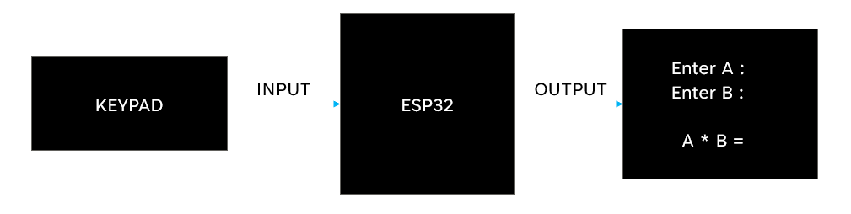
Block-diagram:
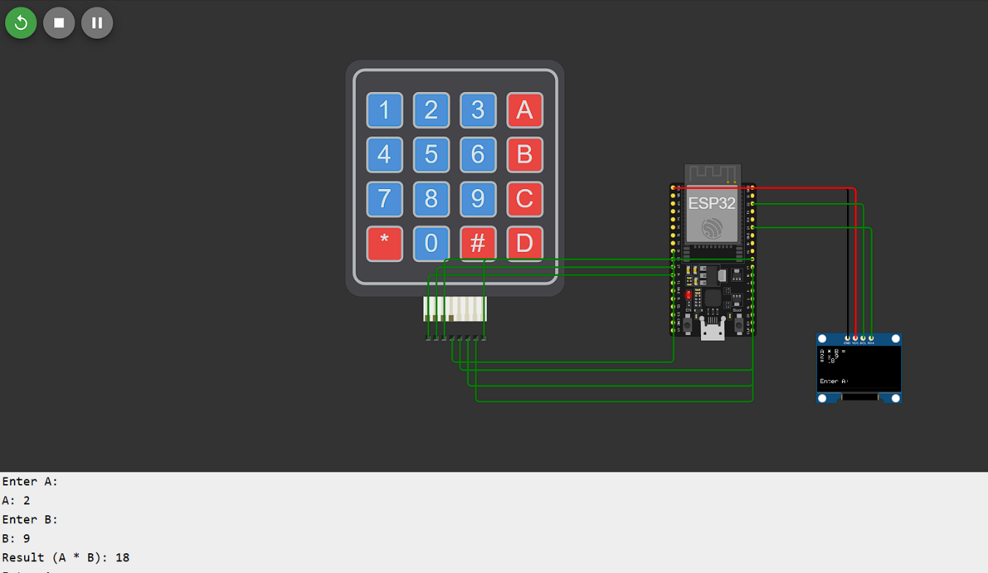
CONNECTIONS:

RESULT:
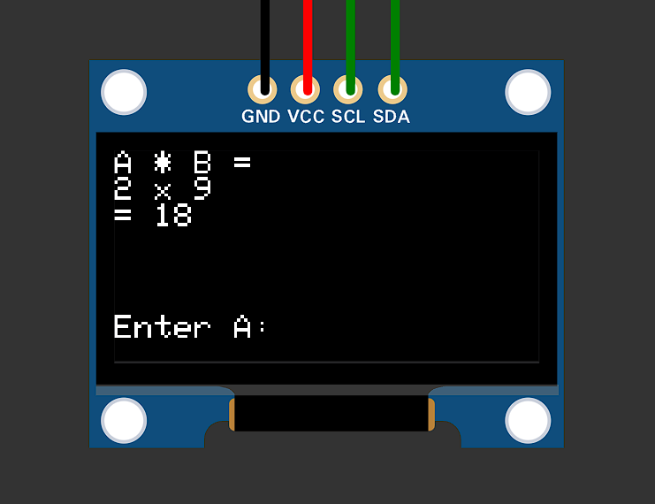

CODE:
#include <Wire.h>
#include <Adafruit_GFX.h>
#include <Adafruit_SSD1306.h>
#include <Keypad.h>
#define SCREEN_WIDTH 128
#define SCREEN_HEIGHT 64
Adafruit_SSD1306 display(SCREEN_WIDTH, SCREEN_HEIGHT, &Wire, -1);
const byte ROWS = 4, COLS = 4;
char keys[ROWS][COLS] = {
{'1', '2', '3', 'A'},
{'4', '5', '6', 'B'},
{'7', '8', '9', 'C'},
{'*', '0', '#', 'D'}
};
byte rowPins[ROWS] = {14, 27, 26, 25};
byte colPins[COLS] = {4, 16, 17, 5};

Keypad keypad = Keypad(makeKeymap(keys), rowPins, colPins, ROWS, COLS);
String inputA = "", inputB = "";
bool isInputtingA = true;
void setup() {
Serial.begin(115200);
if (!display.begin(SSD1306_BLACK, 0x3C)) for (;;);
display.clearDisplay();
display.setTextSize(1);
display.setTextColor(SSD1306_WHITE);
display.setCursor(0, 0);
display.println("Enter A:");
display.display();
Serial.println("Enter A:");
}
void loop() {
char key = keypad.getKey();
if (key) {
if (key == '#') {
if (isInputtingA) {
display.clearDisplay();
display.setCursor(0, 0);
display.println("Enter B:");
display.display();
Serial.println("\nEnter B:");
isInputtingA = false;
} else {
int a = inputA.toInt(), b = inputB.toInt();
int result = a * b;
display.clearDisplay();
display.setCursor(0, 0);
display.println("A * B =");
display.print(a);
display.print(" x ");
display.println(b);
display.print("= ");
display.println(result);
display.display();
Serial.println("\nResult:");
Serial.print("A: ");
Serial.println(a);
Serial.print("B: ");
Serial.println(b);
Serial.print("A * B: ");
Serial.println(result);
inputA = inputB = "";
isInputtingA = true;
display.setCursor(0, 50);
display.println("Enter A:");
display.display();
Serial.println("\nEnter A:");
}
} else if (key == '*') {
if (isInputtingA) inputA = ""; else inputB = "";
display.clearDisplay();
display.setCursor(0, 0);
display.println("Cleared input.");
display.display();
Serial.println("\nCleared input.");
} else {
if (isInputtingA) {
inputA += key;
display.clearDisplay();
display.setCursor(0, 0);
display.print("A: ");
display.println(inputA);
display.display();
Serial.print("\rA: ");
Serial.println(inputA);
} else {
inputB += key;
display.clearDisplay();
display.setCursor(0, 0);
display.print("B: ");
display.println(inputB);
display.display();
Serial.print("\rB: ");
Serial.println(inputB);
}
}
}
}

TASK-3

TASK-4

LITHIUM-ION BATTERIES:
Lithium-ion batteries are rechargeable energy storage devices widely used in electronics, electric vehicles, and renewable energy systems. They consist of four main components
Anode
-> Made up of Graphite
Cathode
-> Made up of Lithium metal oxide
Electrolyte
-> Made up of lithium salt
Separator
-> Made up of Polyethylene (PE), Polypropylene (PP)
Working of lithium-ion batteries:
Charging Process:
- When the battery is charged, an external voltage (charger) forces lithium ions to move from the cathode to the anode through the electrolyte.
- At the same time, electrons are released at the cathode and travel through the external circuit to the anode. The electrons cannot travel through the electrolyte, so they take the external route to the anode.
Discharging Process:
- During discharge, when the battery is powering a device, lithium ions move from the anode back to the cathode through the electrolyte.
- Electrons flow from the anode to the cathode through the external circuit, providing electrical energy to the load

Series Combination:
- The positive terminal of one battery connects to the negative terminal of the next.
The total voltage is the sum of the voltages of all batteries.
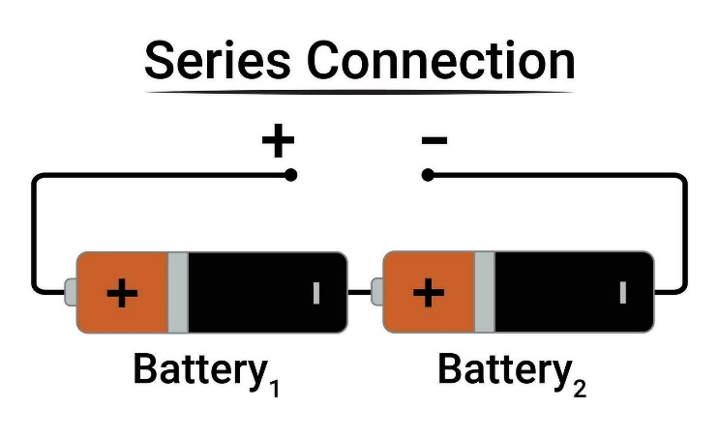
V_total = V1 + V2 + ⋯ + Vn​
- The current remains the same as that of a single battery.
I_total= I1 = I2 = ⋯ = In​

Parallel Combination:
- In parallel combination all positive terminals are connected together, and all negative terminals are connected together.
- The voltage remains the same as that of a single battery.

V_total = V1 = V2 = ⋯ = Vn​

- The total current is the sum of the currents of all batteries.
I_total = I1 + I2 + ⋯ + In​
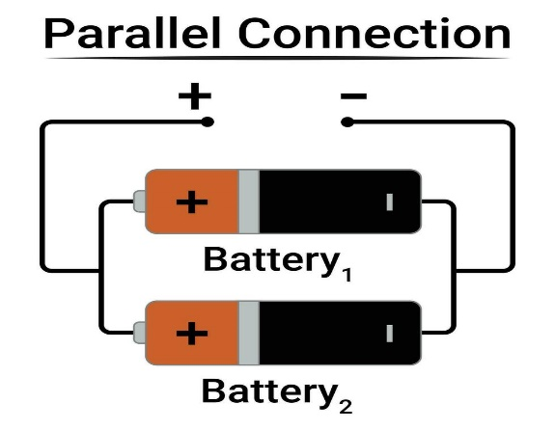

Battery Bank:
A battery bank is a group of batteries connected in a combination of both series and parallel
Series-Parallel Combination:
  - Purpose: Achieves both increased voltage and capacity.
  - Example: Two sets of 12V, 100Ah batteries in series (24V) connected in parallel will give 24V, 200Ah.
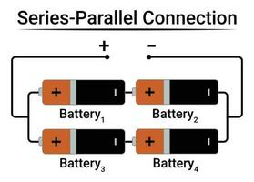

Battery Balancing:
It is a process of equalizing the voltages among individual cells
- Passive Balancing:
  - Excess energy from fully charged cells is dissipated as heat through resistors.
  - Simple but inefficient for large systems.
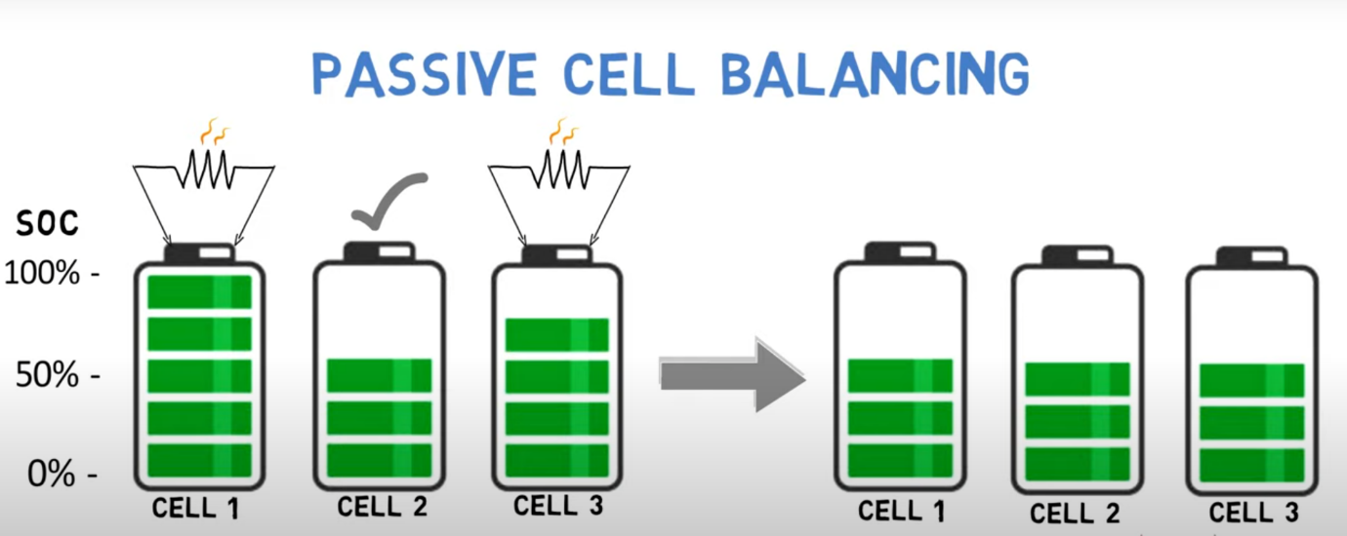

- Active Balancing:
  - Energy is transferred from higher-charged cells to lower-charged ones using circuits.
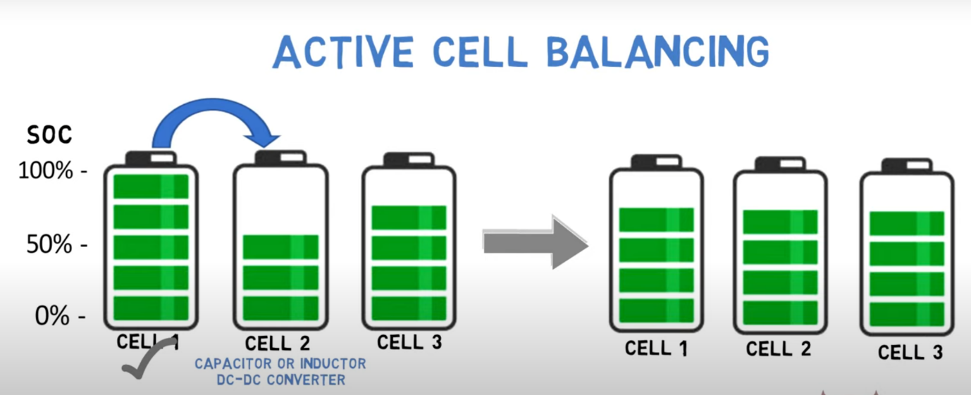
  - More efficient, ideal for high-capacity systems.

